**8/18/22**

Forms of Government Notes:

**Autocracy**

* One person has all the power
* Two main types: monarchy/dictatorship

**Monarchy**

* king/queen rules the country
* King or queen is known as the monarch
* Come to power through family line, current kings/queens oldest child becomes next queen/king
* Olden times, Have final say over government
* Modern times, share power with other parts of government

**Dictatorship**

* One leader with absolute control over the people
* Has control over things, like a constitution
* Parts of government do what the dictator wants

**Democracy**

* Citizens hold power
* Two types of democracies: representative/direct

**Representative democracy**

* The people elect leaders to represent them in government
* They do all the necessary things to keep the country running
* Citizens hold ultimate power, if they don’t like what their representatives do, they can vote new representatives

**Direct democracy**

* No representative, people directly involved in governing the country
* Might be required to participate in lawmaking or judges
* Most modern countries too large for direct democracy to work

**Oligarchy(oligarchy- rule by a few)**

* Small group of people hold all the power
* Only certain group has political rights
* Few people control the country
* Junta - small group of people (usually military officers) who rule a country after taking it by force
* Junta operates kind of like a dictatorship

**Theocracy(theo = God)**

* Government that puts God or a divine being as the ultimate authority
* Religious law settles

**8/19/22**

**Public Policy**

* The goals and programs our government creates and implements for society (to create order and take care of people)
* Complicated process - involves various stakes and “inputs”
* Inputs: voters, media, special interest groups(organization that are non-governmental), politicians

**Role of Government**

* What should the government do? (National, state and local)
* National government - government of the U.S., federal government
* State government - governor, make a lot of rules/regulations for California, whether constitution does not discuss is left to the states
* Local government - mayor, city council, school board
* Answers varu. Ideas differ.
* We do agree on some basic things!
* Limited government
* Rule of law
* Social contract
* Democracy

**Tonight’s Reading Notes: Liberal & Conservatives**

DQ: What are some examples in which libertarians would like the government to take minimal take action?

*The Ideas that Divide Us*

* Most Americans are united through key values (democracy, freedom, and equality)
* We are dramatically different; regilionm education geographically, and backgrounds
* This creates different opinions politically and can divide us

Ideologies - different belief systems

* Our ideologies depend on the arguments we make to back them up
* Our debate is narrow in the U.S. compared to other countries
* No communist or socialist parties in the U.S.
* Two main ideological camps, liberals(Democratic Party) and conservatives(Republicans)
* Conservatives form a political opinon from traditional social values, distrust of government action, resistance to change, and social order
* Liberals form a political opinon from potential for progress and change, trust in government, innovations to answer societies problems, and expansion of individual rights/expression

*The Economic Dimension*

* Since FDR and Great Depression, conservatives and liberals differ on how much they should trust the government
* Conservatives = not trust gov with too much power
* Liberals = willing to trust gov more to regulate economy
* Conservatives = right
* Liberals = left

*The Social Order Dimension*

* People divided on how much of the government’s role should partake in controlling their lives
* Conservatives view of social order = emphasize religion in public life, no abortion/suicide, promote traditional family values(no gay marriage/rights), “American Way”(no diversity/restricting immigration), people should know their place in society, block anything that promotes the opposite of this
* Liberals view of social order = preserve environment, community of equality/protect minorites, individual safety(gun control laws)

*The Relationship Between the Two Ideological Dimensions*

Economic liberals - willing to let government make decisions about the economy and like individualistic positions in social order

* Favor housing subsidies for the poor
* Taxing to support social programs
* Affirmative action
* Prefer individuals to have full freedom on noneconomic terms
* Value diversity/expanding rights to those who were left out

Economic conservatives - dont want government to interfere with peoples private lives and that gov should limit their role in economy too

* Lessen role of decision making to relugate the market
* Eliminate unfair trade practices
* Provision of some public goods
* Open policies to immigrants

Libertarians - extreme holders of economic conservative views, believe that only minimal government action is necessary

Social liberals - like some government role to achieve more equal distribution of material resources and want some role in social order too

* Like freedom to make individual moral choices
* Want government action for diverse and equal power structure and regulate to better health and safety

Communitarians - extreme of social liberalisms, strong commitment to community by equality of all people

Social conservatives - want limited government involvement economically but less forcefully than conservatives

* Concern of moral life
* Emphasize funadmentalist religious values and traditional family roles(gov control of reproductive choices)
* Reject change or diversity
* Immigration is a threat, dilutes social order
* Protect moral character, like a community thatemphasizes hierarchical order over equality
* Like a large/powerful state

Class Discussion:

Ideologies - set of beliefs about politics and society that help us make sense of the world(parents most influence this)

U.S - 2 primary ideological camps

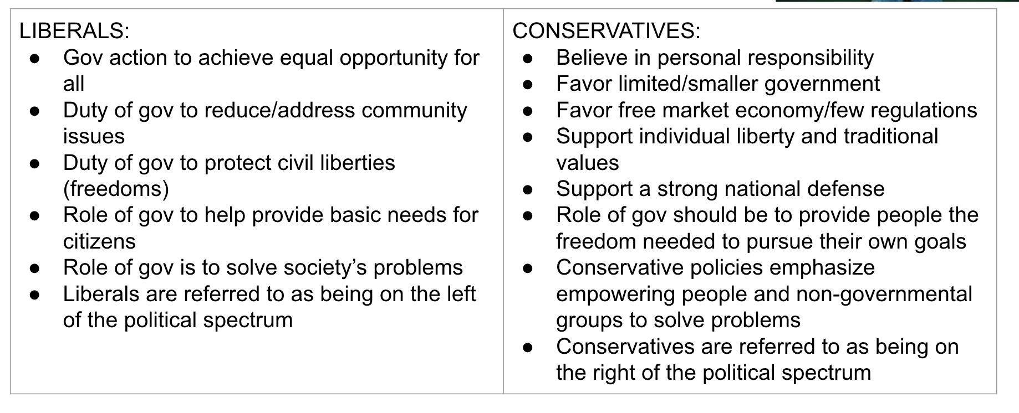

* Most Americans are somewhere in the middle of the political spectrum and are not extreme in their views(called moderates)
* **Republican and Democrat are NOT ideologies, they are parties…it’s different!**
* Many conservative and liberal political parties. R’s/D’s are just the two biggest ones in US poltiics

Liberals - Democrats, Green Party

Conservatives Republicans, Reform Party

Libertarians - conservative, consistent about little government intervention

1930’s Key time period - Great Depression

-New ideas on government intervention(more of it) - more liberal

Polarization

-means being farther apart in views

-L and C are MORE polarized in recent years

Why? Lots of theories: media, social media, weak parties, a primary system with low voter turnout(mostly those more extreme), little incentive for one party to “help” the other party govern after an election

-Polarization makes compromise harder

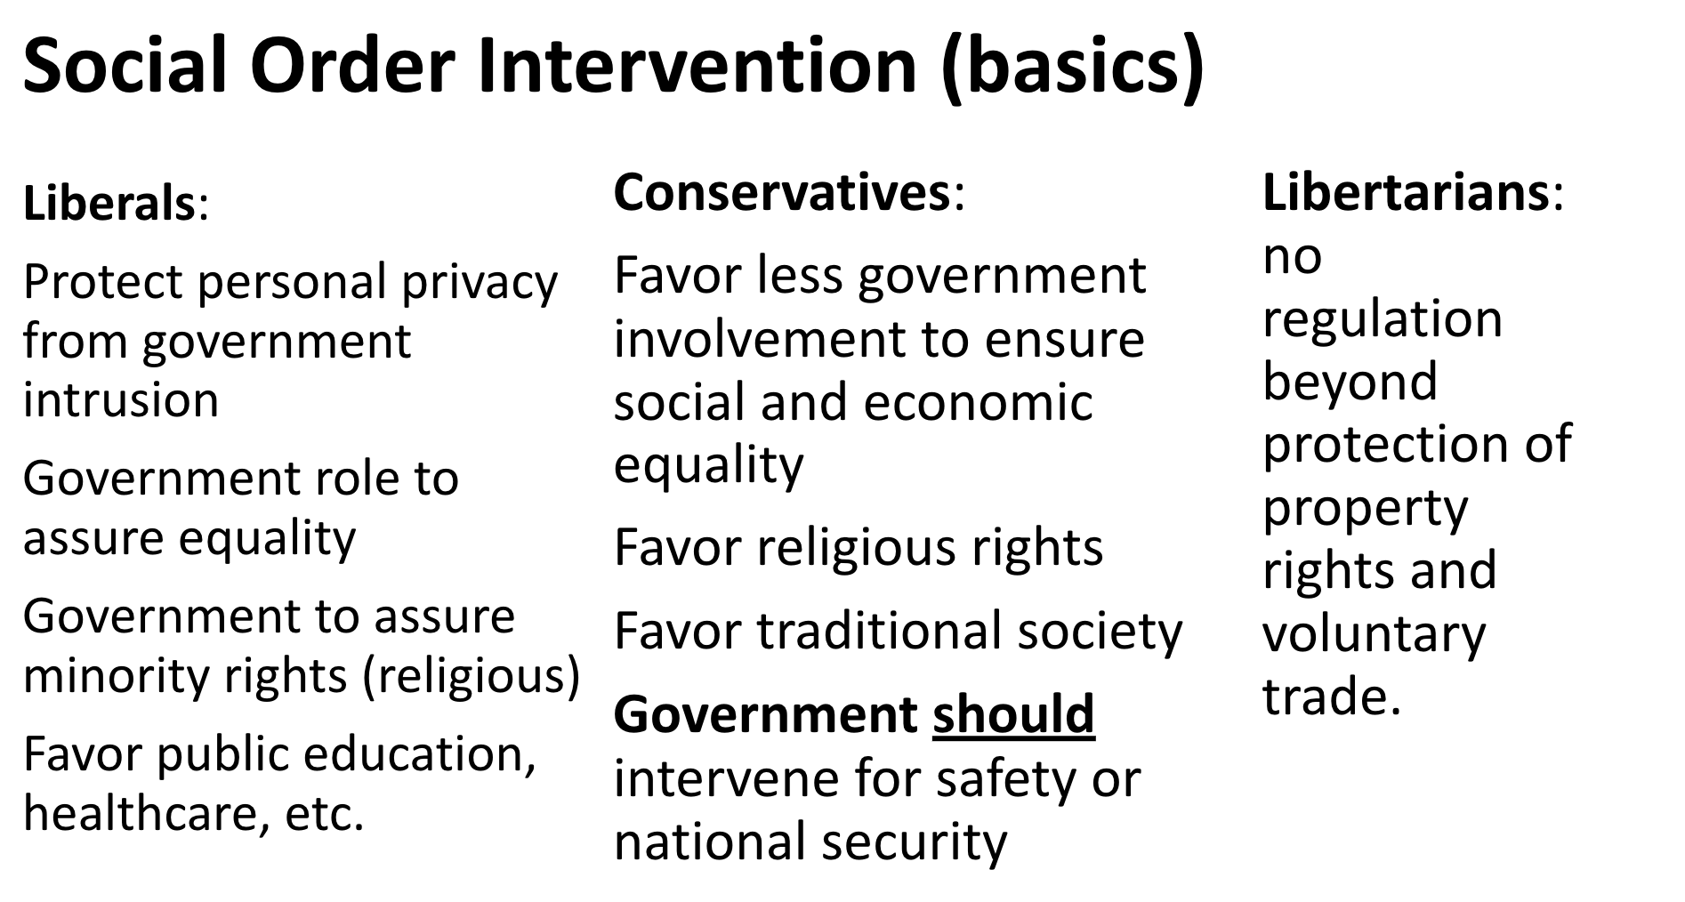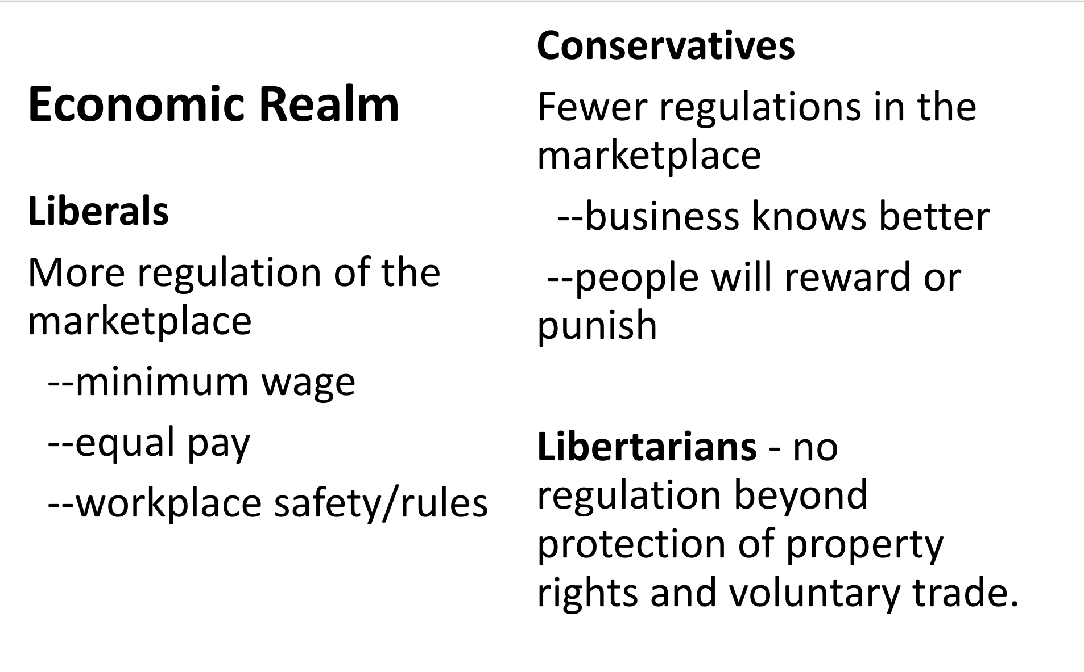

8/23/22 Notes

-Vouchers

-Public education is paid for by taxpayer dollars, mostly by state taxes

-some fed gov money, but constitution says nothing about education, thats why states mainly pay for it

**8/23/22**

**Media Lecture Notes**

*Types of Media*

Print - it is hardcopy, like newspapers

* Less readers of Print media
* Influential, don’t want to see newspapers die out
* More politically active
* MORE reporting
* Ex: NYT, LA Times, WAPO

Broadcast Media - news from the TV or radio

* Where most people get there news
* Ex: ABC, CBS, NBC, CNN, etc.
* Talk radio - radio host where people come on and you interview them, not scripted, very partisan
* Internet - changed media and a lot more people need it
* Mix of sites, a lot are inaccurate

*How Media Works*

* Profit, most driven by this
* They get it from advertising
* Conglomerates
* Can watch two different news station and they could actually both be owned by Disney, so should look at a variety of stations
* Professional Code of Ethics - Truthful, accuracy, etc.
* Correct themselves
* Reliable sources

*Source Types*

* “On-the-record” - can be quoted, nothing has to be hidden, can use name and everything
* “On background” - dont use my name, but you can quote me, you can also give some hint as to where I work
* “On deep background” - take away more information, source is more deeply hidden, no quote directy but paraphrase allowed, can’t name person or where they work
* “Off the record” - nothing can be used, no information can come out, basically research for the reporter

*Roles of the Media*

* Gatekeeper - the media can control and determine what and how long something can become a national political issue, they determine whats important to us and whats not
* Watchdog - Responsible of keeping track what the government does that might be wrong (Ex: Watergate scandal)
* Score Keeper - candidate does something or says something that is not great or good, makes politicians more careful with what they do
* Agenda Setter - similar to gatekeeper, helping the public decide what is important, whether public think is important is what the government is going to address

**8/24/22**

**Fake News**

* Intential false information published as a fact
* NOT satire
* NOT an unintentional mistake
* NOT true information that you disagree with
* NOT editorial

*How to Tell If it’s Fake News*

* Look at the URL - .co, .lo, .com.
* Check the “About Us” section
* Is there an address, location, staff?
* Who is the author? Do they have some credibility, Reporter?
* Check news on a factcheck site, factcheck.org or snopes.com
* Avoid provocative headlines
* Are there ridiculous statements?
* Avoid headlines or stories that use ALL CAPS
* Clickbait = “X reasons why…”

*How to tell if it’s fake news or satire*

* If it sounds like a joke

*Conspiracy theories*

* Conspiracy sources published unverified information that relates to known conspiracies (Aliens, Illuminati, etc.)
* Psuedoscience is similar, punlishes unverified health and scientific claim

*Confirmation Bias*

* Confirmation bias leads you to believe information just because you happen to agree with and discount the parts you don’t
* Just because you think i’ts true doesn’t make it true
* If your goal is to find the truth - you need to use critical thinking skills to evaluate the validity of information

**8/26/22**

**AP Government Current Events**